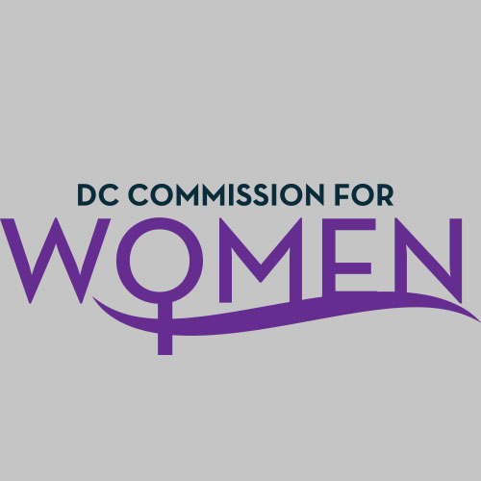
DC Commission for Women
Time: 6:30pm-8:00pm
Date: Tuesday, November 14, 2017
Location: Conference Call: 1-712-770-4700
Participant Code: 428857#

- Call meeting to order: The meeting was called to order at 6:40pm
- Roll Call: Done at 6:42pm. A quorum was met to conduct the meeting.
- MOWPI Staff: Director Kimberly Bassett; Shana Armstrong; Krishna Ghodiwala
- Meeting Minutes: Meeting minutes from October 3, 2017 were circulated and approved with no edits.
- Correspondence & Announcements: None
- Unfinished Business: None
- New Business
  - Chairwoman’s Report: MOWPI
    - Chairwoman Rudd provided kudos and accolades to a successful #BeTheMovement Women’s Leadership Conference. The Chairwoman invited Commissioners to give their feedback on the conference.
    - Commissioner Tomkin thought the conference went smoothly but wanted to ask the Commissioners their thoughts on next steps to keep DC women engaged in the movement.
    - Commissioner Brockington concurred on a wonderful well planned event, however needed feedback concerning the vendors.
    - Commissioner Nelson stated the energy was great and attendees were excited to learn about the topics of our breakout sessions.
    - Commissioner Porter shared how encouraged attendees were upon leaving the Run for Office workshop.

  - MOWPI Director’s Report:
Director Bassett shared the activities of the MOWPI office to include:
    - Director Bassett commented on the success of the #BeTheMovement Women’s Leadership Conference and thanked the Commissioners for their support and wide attendance during the conference.
    - Congresswoman Eleanor Norton was extremely honored and pleased to receive the 1st #BeTheMovement Leadership Award from Mayor Muriel Bowser and the DC Commission for Women.
    - MOWPI staff is beginning to plan our 2018 events.
    - Converstations with Women Who Lead in Food will be held in the early winter months.
    - Our popular series, Fresh Start Wednesdays will begin in February at the RISE Center. We want all Commissioners to participate and give suggestions for new topics for the weekly sessions.
    - Women of Excellence Awards is scheduled to be held in March, more details on will be shared at future meetings.
    - WorkSmart Salary Negotiation classes will continue in 2018.
    - Mayor Bowser’s Holiday Reception on Wednesday, November 29th.

- Announcements & Good of the Order
- Commission Holiday Reception will be tentative held on Thursday, Dec. 14th.

- Next Meeting Date: The next meeting will be on January 9, 2018 at the Wilson Building.

- Motion to Adjourn: Meeting adjourned at 7:15pm.

