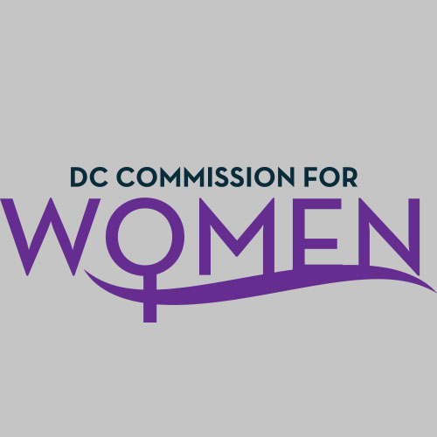
DC Commission for Women
Time: 6:45pm-8:00pm
Date: Tuesday, January 9, 2018
Location: 1350 Pennsylvania Avenue Room G-9
Conference Call: 1-712-770-4700
Participant Code: 428857#

- Call meeting to order: The meeting was called to order at 6:50pm
- Roll Call: Completed at 6:52pm. A quorum was met.
- MOWPI Staff: Director Kimberly Bassett; Shana Armstrong
- Meeting Minutes: Meeting minutes from November 14, 2017 were circulated and approved with no edits.
- Correspondence & Announcements: Special guest, Charon Hines- Director of Community Affairs discussed Mayor Bowser’s Accountability Report and six month calendar of events.
- Unfinished Business: None
- New Business
  - Chairwoman’s Report:
    - Chairwoman Rudd reviewed her #BeTheMovement evaluation report with intention of using the document to plan the 2018 Leadership Conference.
    - The Commission Annual Report will be submitted to MOWPI by the end of January.
    - Committees are asked to meet before the February meeting and plan their area of focus for 2018.

  - MOWPI Director’s Report:
    - Director Bassett announced the special guest for Conversations with Women Who Lead will be ABC’s The Chew co-host and Bravo Top Chef alum Carla Hall! The MOWPI staff is currently looking for venues that can accommodate 250-300 people on Monday, January 29th.
    - Fresh Start Wednesdays will begin on February 21st from 5:30-7:00pm. The 10-week series occurs every Wednesday at UDC-Bertie Backus campus. If you would like to participate in the program or know of an inspirational figure to speak to attendees, please inform MOWPI team.
    - Women of Excellence Awards take place on Sunday, March 4th from 4:00-6:00pm at the Capital Yacht Club. Please send your nominations to the MOWPI staff. Keep in mind all nominees must live and work in the District of Columbia, their cause should elevate the lives of women and girls.
    - MOWPI is partnering with the Mayor’s Office of Veterans Affairs to design a license plate honoring women veterans.
    - WorkSmart Salary Negotiation classes will continue in 2018. If Commissioners are interested in becoming a trainer for the program, please inform MOWPI staff.
    - The 12th Annual MLK parade is on January 15th, we are asking all Commissioners to walk with us at the parade. Please check your calendar for details.
    - February is Heart Health Month. Our office wants to draw awareness to this issue which is the leading cause of death in women. Commissioners are asked to inform the MOWPI staff of any events surrounding heart health.

- Announcements & Good of the Order
- No Announcements

- Next Meeting Date: The next meeting will be on February 6, 2018 at the Wilson Building.

- Motion to Adjourn: Meeting adjourned at 7:25pm.

