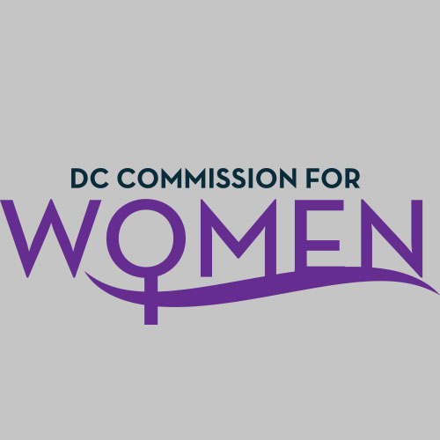
DC Commission for Women
Time: 6:45pm-8:00pm
Date: Tuesday, April 3, 2018
Location: 1350 Pennsylvania Avenue Room 527
Conference Call: 1-712-770-4700
Participant Code: 428857#

- Call meeting to order: The meeting was called to order at 6:51pm
- Roll Call: Roll call was completed at 6:53pm. A quorum was met.
- MOWPI Staff: Alex Chambers; Shana Armstrong
- Meeting Minutes: Meeting minutes from Feb 6, 2018 were circulated and approved with no edits.
- Correspondence & Announcements: None
- New Business
  - Chairwoman’s Report:
    - Retreat planning in July: Jennifer and Abigail are taking the lead on planning the location, date, and activities of the retreat. The tentative month of the retreat will be in July. If you would like to help with planning the event, please contact Jennifer Porter and/or Abigail Truhart.

- Committee Reports
- Policy & Legislative Initiatives Committee: Shelley Tomkin, & Princess McDuffie, Chairs
- The committee discussed issues presented like Violence Against Women; Mortality Against Black Mothers; Sexual Harassment; Resources for Returning Citizens and Homeless Women.
- Law 21-201: the Feminine Sales Diaper and Tax Exception was approved for funding in the FY2019 budget. We have identified a significant need for these products to give to shelters.
- MOWPI will invite Director Laura Zeilinger to an upcoming meeting to speak about the status of the homelessness in DC.

- MOWPI Director’s Report:
  - Special thanks for Commissioners’ support during the Women of Excellence Awards. Women of the community are now inquiring how to become a Woman of Excellence.
  - Equal Pay Day is on Tuesday, April 10th at the Wilson Building, and we will have a Work Smart Salary Negotiation workshop in celebration of the day. Equal Pay Day is the approximate day a woman must work into the new year to make what the average man made at the end of the previous year. Based on the ACS Census data, the 2018 wage gap between women and men is $0.80 (cents).
  - Fresh Start Wednesdays kicked off with a large attendance at University of District of Columbia-Bertie Backus for our Financial Planning workshop with Department of Securities, Insurance and Banking’s facilitator Michelle Hammonds. Commissioners are welcome to come speak at the workshops.
  - The Mayor’s Office invites all Commissioners to attend the DC Emancipation Day parade and day of activities on April 14th.
  - Jenifer Smith, Director of Office of Forensic Sciences and her office wants to partner with MOWPI to coordinate a science workshop for women. The tentative date is May 26th.
  - A new staff member joined the MOWPI team, Alex Chambers! She will serve as the Public Information Officer.
  - Mark your calendars for August 26th, Women’s Equality Day. Everyone is encouraged to wear yellow to commemorate the occasion.

- Announcements & Good of the Order
- None

- Next Meeting Date: The next meeting will be on September 4, 2018 at the Wilson Building.

- Motion to Adjourn: Meeting adjourned at 7:35pm.

