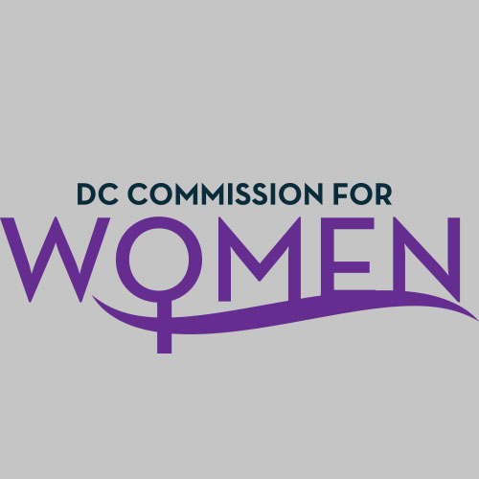
DC Commission for Women
Time: 6:45pm-8:00pm
Date: Tuesday, October 9, 2018
Location: 1350 Pennsylvania Avenue Room 527

- Call meeting to order: The meeting was called to order at 6:57pm
- Roll Call: Roll call was completed at 6:58pm. A quorum was met.
- MOWPI Staff: Alex Chambers; Shana Armstrong
- Meeting Minutes: Meeting minutes from April 3, 2018 were circulated and approved with no edits.
- Correspondence & Announcements: None
- New Business
  - Chairwoman’s Report:
    - Chairwoman Porter held a moment of silence for Commissioner Ann Marie Habershaw who passed away in September.
    - Special thanks to all Commissioners who attended the Women’s Equality Day Celebration, opening of Excel Academy, and supported MOWPI throughout the summer.

- Committee Reports: No committee reports at this time.

- MOWPI Director’s Report:
  - Women’s Equality Day was a huge success. Symone Sanders, CNN Correspondent, emceed with over 700 women in attendance.
  - October is Domestic Violence Awareness Month; MOWPI will host an event at House of Ruth on October 17th discussing self-care and healthy relationships.
  - DC enacted legislation to end the practice of charging sales tax on menstrual hygiene products. MOWPI staff worked with the Mayor’s Communications team to make a video to promote the new law.
  - On October 11th, Mayor Bowser and MOWPI will discuss various issues affecting girls today at Columbia Height Educational Campus among their middle and high school students to commemorate the International Day of the Girl.
  - Since 2016, our groundbreaking Work Smart Salary Negotiation workshops with AAUW have trained over 3,000 women, and we are requesting all Commissioners to sign up for workshop training.

- Announcements & Good of the Order
- Director Bassett announced Jennifer Porter as the Chairwoman for the DC Commission for Women!

- Next Meeting Date: The next meeting will be on November 13, 2018 at the Wilson Building.

- Motion to Adjourn: Meeting adjourned at 7:50pm.

