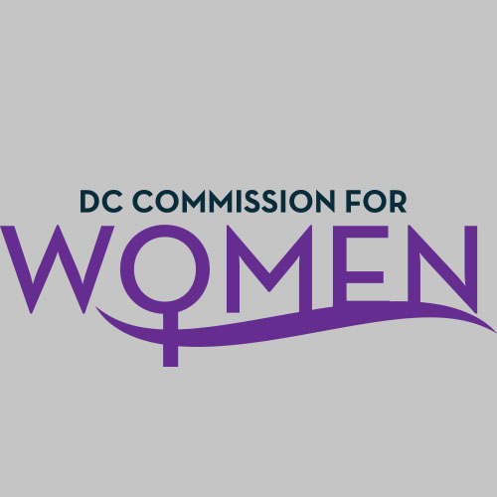

DC Commission for Women
Time: 6:45-8:00pm
Date: Thursday, November 12, 2015
Location: John A. Wilson Bldg, 1350 Pennsylvania Ave. Room G-9, Washington, DC 20004

- Call to Order: Meeting called to order at 6:50pm.

- Roll Call: Commissioners in attendance.
MOWPI Staff: Associate Directors, Shana Armstrong, and Krishna Ghodiwala
A Quorum was not met to conduct business requiring a vote. The meeting was informational only.
- Overview of the State of Homelessness: Dept. of Human Services Director Laura Zeilinger highlighted the mission, objectives, and strides DHS is making towards the Mayor’s pledge to end homelessness in the District of Columbia. Director Zeilinger gave a summary of DHS Homeless Services which includes the Economic Security Administration. The ESA oversees food stamps, TANF, Medicaid and job training resources. Director Zeilinger’s insightful advice and feedback worked to shape the Commission’s strategy toward addressing homelessness in 2016.

- Recap of Retreat: Feedback from the evaluations of the Commission retreat indicates the event was an overall success! The Commission agreed to focus on bringing awareness to eradicating homelessness to align with the Mayor’s vision to end this epidemic in the District by 2020.

- Correspondence/Notifications: None presented.

- Unfinished Business: None presented.

- New Business: MOWPI staff will send dates for Commissioners to participate in feeding the homeless during the season of Thanksgiving. The Health and Human Services committee asked all Commissioners to support the Aware & Care DC initiative focusing on bringing awareness to homeless families in the District.

Committee Reports
Education Labor & Training: Comm. Butler, Chair
No updates presented.

Health & Human Services: Comm. Upadhyay, Chair
Commissioner Hacskaylo discussed the Aware and Care initiative and volunteer opportunities for the Thanksgiving holiday season at various organizations benefitting homeless women and/or families.

Public Affairs: Comm. Fenton, Chair
No updates presented.

Policy & Legislative Initiative: Comm. Frazier, Chair
The following upcoming/pending legislation was shared:
Women in Need Program Amendment Act (B210367): To make bill more comprehensive and inclusive around women who are incarcerated, homeless, etc.
Employment Protections of Domestic Violence (B21211): Broaden bill to allow for “safe haven” in reporting abuse; partnering with private sector to ensure no job loss.
Local Implementation of Convention on Elimination of All Forms of Discrimination Against Women Act of 2015 (CEDAW): Confirm current stats of LGBTQ within the District Government.

Public Safety: Comm. McDuffie, Chair
No updates presented but planning call will be scheduled soon.
Updates from MOWPI: Special thanks to all Commissioners for their participation in generating energy around Purple Thursday, October 22nd (Domestic Violence) and Pink Friday, October 23rd (Breast Cancer). MOWPI received great support and social media participation from other agencies within the DC government!
MOWPI concluded the Domestic Violence Awareness Drive on October 30th and collected items valued at over $17,000 to benefit My Sister’s Place and DASH.
On Tuesday, October 27th, MOWPI partnered with the Health Alliance Network of Ward 7 and Breast Care for Washington to host an in-depth discussion entitled, Let’s Talk about Breast Health: Her Story Matters, in honor of Breast Cancer Awareness Month at the Department of Employment Services in Ward 7. Attendees learned about breast cancer prevention and the importance of breastfeeding while hearing expert advice from panelists and enjoying refreshments, treats and health screenings. Mayor Bowser, Councilmember Yvette Alexander, and Department of Health Director, Dr. Nesbitt gave remarks emphasizing the importance of Breast Health while highlighting DC government programs available to provide healthcare resources for those in need. MOWPI sponsors for the event included Amerihealth, MedStar Family Choice, and United Medical Center.
Fresh Start Wednesdays continues to be a success with the most popular workshops focusing on the topic of Entrepreneurship Skills. Attendees range in age and backgrounds including but not limited to returning citizens, seniors, and young mothers. Every Wednesday, from September 9th-November 18th, MOWPI’s intern and SHE DC volunteers provide childcare for the women while they attend sessions and United Planning Organization offers transportation to the Metro station. Participants of the sessions have heard remarks from special guests Councilmember LaRuby May, Deputy Mayor Courtney Snowden and many others! Many commissioners attended one or more of the Fresh Start Wednesday sessions.
In celebration of the Hindu Holiday, Diwali, MOWPI partnered with the Mayor’s Office of Asian Affairs to host the ‘festival of lights’ event on November 5th. US Representative, Ami Bera; US Representative, Tulsi Gabbard; White House AAPI, Aditi Hardikar and Executive Director of the Hindu American Foundation, Suhag Shukla presented remarks to over 350 guests at Old Judiciary Square. The South Asian Performing Arts Network also provided live performances for attendees! Also in attendance were Commissioners and representatives from the Mayor’s Office.
Announcements/Good of the Order: Comm. Chair Rudd will host a holiday party for the Commissioners on December 10th.

Adjournment: Meeting adjourned at 8:30pm. Next meeting will take place in the beginning of 2016, an actual date is forthcoming.

