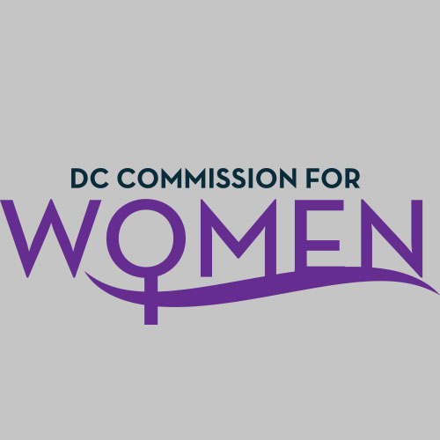
DC Commission for Women
Time: 6:30-7:30pm
Date: Monday, Sept. 19, 2016
Location: Conference Call

- Call meeting to order: The meeting was called to order at 6:33pm
- Roll Call: Commissioners in attendance.
- MOWPI Staff: Shana Armstrong, Krishna Ghodiwala, and Director Bassett.
A quorum was met to conduct the meeting.
- Approval of Previous Minutes: Minutes were circulated and accepted from the previous meeting in May.
- Correspondence: No correspondence to review over the summer
- Unfinished Business: Final review of the Bylaws. Time to review was over the summer. Motion to accept the adoption of the Bylaws with amendments. Monte Monash motioned and Tiffani Greene seconded the motion. Motion unanimously accepted by the Commissioners.
- Committee Reports: No new reports
- New Business:
- Election of Officers for the Commission: No were no objections to current officers serving for another term. However, the Vice Chair position was vacant resulting from the resignation of Shana Heilbron. The officers duly elected for 20116-2017 are as follows:
  - Vice Chair – Commissioner Donella Brockington
  - Secretary – Commissioner Jacquelyn Glover
  - Treasurer – Commissioner Monte Monash
  - Parliamentarian – Commissioner Ferial Bishop
  - Chair – Commissioner Carolyn Rudd
(The Chair is appointed by the Mayor and does not require a vote by the Commission body.)
- Committees: The current committee chairs agreed to continue to serve. We have one vacant Committee Chair position to be filled.
- Public Safety – Commissioner Princess McDuffie
- Policy and Legislative Initiatives – Commissioner Endrea Frazier
- Public Affairs – Commissioner Abby Fenton
- Health and Human Services – VACANT
- Education, Labor and Training – Commissioner Brandy Butler
- Director Bassett
  - Director Bassett gave a special thanks to everyone for their support during the summer at workshops and events hosted by MOWPI.
  - Fresh Start Wednesdays at the RISE Center had a very successful closing in August with presentations by Celebrity Stylist, George Worrell and DC Unified Communications Director, Karima Holmes.
  - Over 400 women attended our 2nd Annual Women’s Equality Day in August, which is a celebration of the day women were granted the right to vote on August 26th. Mayor Bowser spoke and we saw an enormous amount of support from our partner organizations and DC Government senior leadership.
  - Work Smart volunteer facilitators are needed. We have a list of 350 women who are on the waitlist for the workshops. Please correspond with Shana to receive more details on how you can help.
  - The Mayor’s Women Tea is set for October 2nd from 3-5pm.
  - MOWPI has Breast Cancer and Domestic Violence events scheduled in October, details are forthcoming about specific events for the month.

- ANNOUCEMENTS
  - Commissioners should provide their organizational events to the MOWPI staff for sharing with all the Commissioners.

- Motion to Adjourn: The meeting adjourned at 7:05pm.
- Next meeting is on Tuesday, Oct 4, 2016 at 6:45pm at the Wilson Building
- October Meeting Topics:
  - Combining the Committees
  - Girls Conference
  - Bylaws

