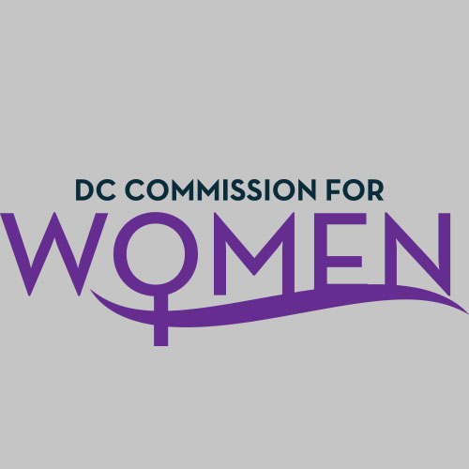
DC Commission for Women
Time: 6:45-8pm
Date: Tuesday, October 4, 2016
Location: John A. Wilson Building, 1350 Pennsylvania Ave. Room 527, Washington, DC 20004

- Call meeting to order: The meeting was called to order at 6:52pm
- Roll Call: Commissioners in attendance. A quorum was met to conduct the meeting.
- MOWPI Staff: Director Kim Bassett, Shana Armstrong, and Krishna Ghodiwala.
- Approval of Previous Minutes: Minutes were circulated and accepted from the previous meeting in September.
- Correspondence: No correspondence to review.

- New Business:
  - COMMITTEES: The Commission now has three committees versus five. The Committees are as follows:
- Policy and Legislative Initiatives – Commissioner Endrea Frazier, Chair
- Health and Human Services & Public Safety - Commissioner Princess McDuffie, Chair
- Education, Labor and Training – Commissioner Brandy Butler, Chair
- Committee Reports: No new reports
- Director Bassett
  - The Mayor met so many new women of the District at the Women’s Tea and she thoroughly enjoyed it. Around 400 women were present and she wanted to extend a special thank you to our Commission for your support, dedication, and fresh ideas!
  - STRATEGIC PLAN: Commission received Mayor Bowser’s 18 Month Progress Report and MOWPI Strategic Plan with a calendar of events.
  - The staff met with Denver Women’s Commission to share best practices of events and policy. Both parties were impressed by the work and ideas coming out of each office.
  - Work Smart Salary Workshops will continue throughout the rest of the year and into 2017, we have a waiting list of over 250 people for the workshops.
  - October is Breast Cancer Awareness Month and Domestic Violence Awareness Month. MOWPI will host events for Domestic Violence Awareness Month targeting young women and girls to bring awareness about the signs of domestic abuse.
  - December is World Aids Day and we want to bring attention to how this disease affects a large amount of African-American women in the District. Commissioner Fenton shared some events Whitman-Walker is hosting during the month of December and noted we will receive more information soon.

- ANNOUCEMENTS
No announcements at this time.

- Motion to Adjourn: The meeting adjourned at 7:47pm.
- Next meeting is on Tuesday, Nov. 1, 2016 at 6:45pm at the Wilson Building

