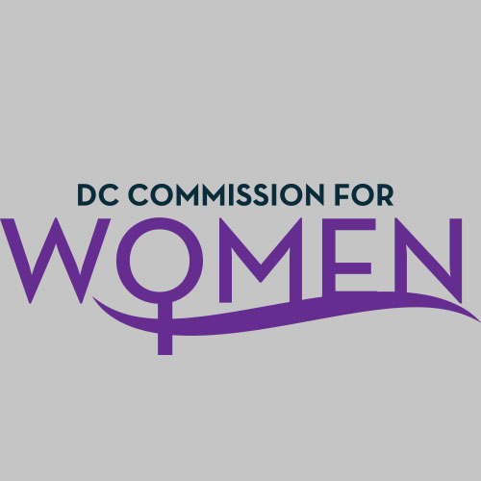
DC Commission for Women
Time: 6:45-8pm
Date: Tuesday, November 1, 2016
Location: Wilson Building, Room 527

- Call meeting to order: The meeting was called to order at 6:52pm
- Roll Call: Commissioners in attendance. A quorum was met to conduct the meeting.
- MOWPI Staff: Shana Armstrong, Krishna Ghodiwala, and Director Kimberly Bassett.
- Approval of Previous Minutes: Minutes were circulated and accepted from the previous meeting in October.
- Correspondence: No correspondence to review.
- Unfinished Business: BYLAWS
- New Business
- CHAIRWOMAN’s REPORT
  - Chair Rudd requested MOWPI to repost Committee Co-Chair information, and have everyone to sign up for committees again to ensure all are accounted for on the list.
  - The committee for the Women’s Policy Conference set for October 2017 includes the following Commissioners: Rudd, Bishop, Brockington, McDuffie, Greene, Habershaw, and Fenton.
  - Annual Report: Please send any specific information for events and items that need to be highlighted to Commissioner Rudd no later than December 14th.

- COMMITTEE REPORTS:
  - Girls Conference Committee (Comm. Endrea Frazier, Chair)
    - The Girls Conference Committee met and Commissioner Frazier sent a written report to MOWPI. The event is proposed to occur on a Saturday in March from 10am -3pm. The theme is focused on having a positive online presence with a target age of 13-18 year old girls. Committee is working with MOWPI to consider how many attendants we want to participate; venue will be determined based on number of participants. In the upcoming weeks, committee is taking suggestions for keynote and guest speakers for the interactive sessions.
    - Need to identify partners for the Committee- Commissioner Bussey has other groups to suggest for partnership opportunities.
    - Committee also suggested having a special session for parents coaching them on how to engage their daughters regarding their usage of social media.

- DIRECTOR’S REPORT
  - October was Domestic Violence (DV) Awareness Month and we were able to get 38 agencies to participate in a successful social media campaign. The DC Department of Forensic Sciences had a food truck to honor those employees who wore purple. MOWPI collaborated with DC Coalition Against Domestic Violence to give a DV workshop in Ward 5, which has one of the highest reported rates of Domestic Violence in the District.
  - Over the next couple of months, MOWPI will focus on planning the Girls Conference and setting up a calendar with AAUW for 2017 Salary Negotiation classes.
  - The Women of Excellence Awards program is awaiting approval from the Mayor regarding women to highlight and plans to move forward.

- ANNOUCEMENTS
  - MOWPI Holiday event is to be held on Dec. 7th and hosted by Commissioner Monash.

- Motion to Adjourn: The meeting adjourned at 7:41pm.
- Next meeting is on Tuesday, Jan. 10, 2017 at 6:30pm via Conference Call

