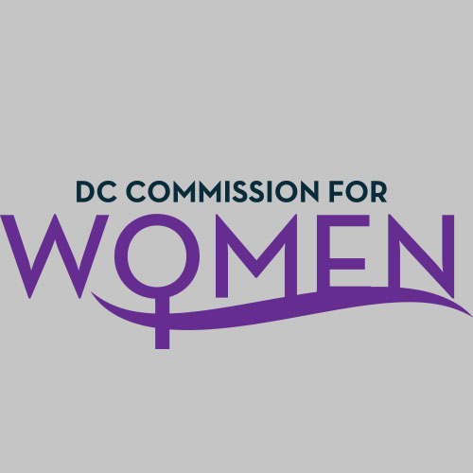
DC Commission for Women
Time: 6:30-8:00pm
Date: Tuesday, January 24, 2017
Location: Conference Call; John A. Wilson Building, 1350 Pennsylvania Ave. Room 527, Washington, DC 20004

- Call meeting to order: The meeting was called to order at 6:30pm
- Roll Call: Commissioners in attendance. A quorum was met to conduct the meeting.
- MOWPI Staff: Shana Armstrong, Krishna Ghodiwala, and Director Kimberly Bassett.
- Approval of Previous Minutes: Minutes were circulated and accepted from the previous meeting in November.
- Correspondence: No correspondence to review.
- Unfinished Business: BYLAWS, Chairperson Rudd stated that adopted bylaws are being circulated to the Commissioners.
- New Business
- CHAIRWOMAN’s REPORT: N/A
- COMMITTEE REPORTS: N/A

- DIRECTOR’S REPORT
  - Director Bassett thanked the commissioners for their involvement in Mayor Bowser’s Fresh Start 5k, MLK parade and the screening of Hidden Figures in partnership of Alpha Kappa Alpha Sorority, Inc.
  - Over the next couple of months, MOWPI will be focused on Fresh Start Wednesday’s; they are starting at a later time to increase attendance. They will be focusing on workshops addressing financial literacy, homeownership and other life skills. Director Bassett is soliciting participation from Commissioners to volunteers.
  - Women’s Policy will be hosting a Girls Conference called POP (Positive Online Presence).
  - The Women of Excellence Awards program is awaiting approval from the Mayor regarding women to highlight and plans to move forward.
  - Director Basset invited the Commissioners to join Mayor Bowser’s Public Safety Call

- ANNOUCEMENTS
  - N/A

- Motion to Adjourn: The meeting adjourned at 7:25pm.
- Next meeting is on Tuesday, Feb. 14, 2017 at 6:30pm

