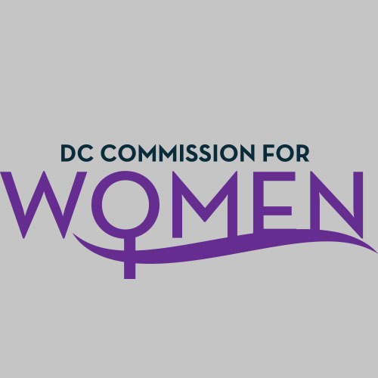
DC Commission for Women
Time: 6:45-8pm
Date: Tuesday, May 2, 2017
Location: John A. Wilson Building, 1350 Pennsylvania Ave. Room 527, Washington, DC 20004

- Call meeting to order: The meeting was called to order at 6:50pm
- Roll Call: Done at 6:50pm. A quorum was met to conduct the meeting.
- Guest Speaker: Kristen Moore with DCPS spoke to the Commissioners about the upcoming We the Girls: Young Women’s Leadership Conference & Pep Rally and REIGN Program.
- See attached Slide Deck for the Event Flyer and Discussion points.
- The three areas of focus for the conference are Future Leaders, Health & Wellness and Gender Identity. A Gallery Walk will feature different organizations advocating for strong educational and social values of girls.
- The Conference held on June 3rd will entail college panels, breakout sessions and a pep rally. Registration for the conference ends on May 31, 2017. To volunteer for the conference, email: Kelly.Stein@dc.gov.
- Commissioners were asked to help promote the event by reaching out to established girl programs and organizations, and encourage them to register.
- The conference is being promoted on the DCPS landing page and flyers are being sent to all the schools. DCPS will also use Twitter, Snapchat and various media outlets to build attendance.

- Chairperson Commissioner Rudd Updates:
- Meeting Minutes Accepted
- Unfinished Business - None
- No New Business
- Commission Retreat will be hosted by Commissioner Frazier again this year. We need some dates to propose. Last year’s event was July 29, 2016. It was decided that this year’s date will be July 28th. This will be an all-day event. The retreat will focus on planning the Women’s Leadership Conference scheduled for the Fall.
- Committee Reports- None

- MOWPI Director Bassett Update:
- We are currently looking for new Commissioners to fill vacancies. Some names of potential Commissioners have been submitted to the Mayor for consideration.
- MOWPI recently concluded the Spring session of Fresh Start Wednesdays. Attendance varied throughout the program and we received great feedback from attendees regarding topics and special guests.
- Conversations with Women Who Lead- Media Edition was held at the National Press Club with an attendance of over 300 people! We thank all Commissioners for their continued support.
- Our WorkSmart Salary Negotiation Classes will continue throughout the year. Each session brings a diverse group of women with a maximum capacity rate per class of 60-80 people. A wait list for each site proves the need for this information in the District. Recently, an article for the program was featured in the Washington Post. Facilitator training occurs throughout the year, please let Director Bassett know if you are interested in becoming a trainer for these classes.
- MOWPI is partnering with various activity and wellness centers to focus on senior women for Summer 2017.
- Director Bassett strongly encourages everyone to attend the Girls on The Run event on Sunday, June 4th.
- The conference will focus on Leadership and helping women get involved in politics and consider running for office.

- Announcements
- Best Friends Foundation Symposium is one that we should consider for us to partner with next year.

- Next Meeting Date: Sept. 12^{th,} 6:45pm @ the Wilson Building.

- Motion to Adjourn: Meeting adjourned at 7:57pm.

