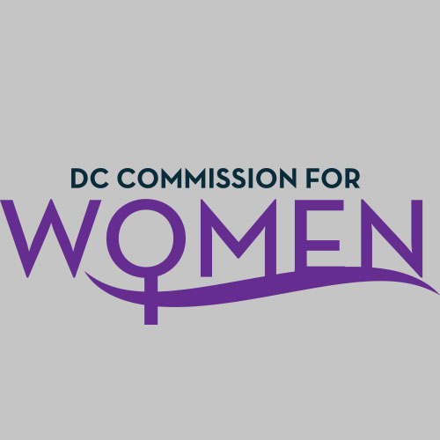
DC Commission for Women
Time: 6:45-8:00pm
Date: Thursday, March 10, 2016
Location: Via Conference Call; John A. Wilson Building, 1350 Pennsylvania Ave. Room G-9, Washington, DC 20004

- Call meeting to order: The meeting was called to order at 6:52pm
- Roll Call: Commissioners in attendance.
- MOWPI Staff: Director Bassett, Shana Armstrong and Krishna Ghodiwala.
A quorum was met to conduct the meeting.
- Approval of Previous Minutes: Minutes were circulated and accepted from the previous meeting.

- Unfinished Business:
  - Commissioner Bishop was not able to update the Bylaws for our review as of yet but is working on them and will present a status update at the next meeting.
- New Business:
- Commissioner Rudd
  - Thank you to all who attended the Women of Excellence Awards and special thank you to Director Bassett and MOWPI staff for all their hard work. It was an excellent program.

- Committee Reports: No new reports

- DIRECTOR BASSETT’s Update
- Thank you to everyone who attended the Women of Excellence Awards and special thank you to Shana Armstrong who spearheaded this event. Mayor Bowser and Councilmember Brandon Todd addressed the crowd of over 200 attendees.
- MOWPI is working with AAUW to support the Equal Pay Day on April 12th. MOWPI will launch this initiative at a press conference for Equal Pay Day. These classes are free and target women ages 25-45.There will be train-the-trainer classes for Commissioners will be asked to become teachers for these classes.
- Conversations with Women Who Lead
  - The focus of the next session will be on Advocacy and Nonprofits.
  - We identified the location for the event at the DOES building in Ward 7 because of its large seating capacity and parking availability.
  - Potential dates are 3/29, 3/30, or 3/31
- The Mayor’s State of the District is on Tuesday, March 22nd at the Arena Stage.
- We were the only Commission to turn in a report for 2015 and everyone was so impressed with our report that it will be used as a template for future Commission reports.
- The Equality Conference has been postponed until later in the year.
- The White House recently held a diaper drive which garnered a lot of press but MOWPI was the first to call attention to this matter in 2015 as mothers do not receive public assistance for diapers.
- Councilmember LaRuby May is hosting the first annual Ward 8 Women’s Impact Awards on Tuesday, March 29th at The ARC in Southeast DC.
- The Natalie Williams Foundation’s Test My Breasts 5K Walk and Wellness Fair will be held on April 2nd at Hains Point in Washington DC to bring awareness on how breast cancer affects women of color and the importance of early detection.

- Motion to Adjourn: The meeting adjourned at 7:15pm.
- Next meeting is on April 7, 2016 at 6:45pm.

