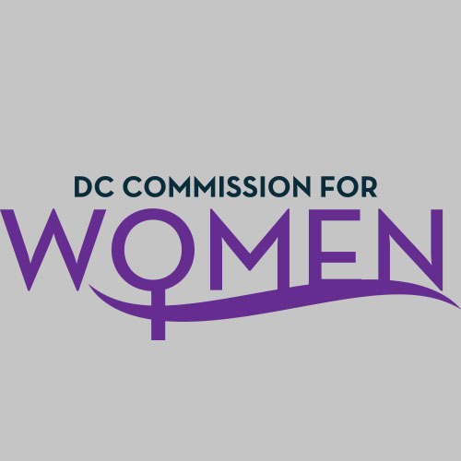
DC Commission for Women
Time: 6:45-8:00pm
Date: Thursday, May 5, 2016
Location: John A. Wilson Building, 1350 Pennsylvania Ave. Room 527, Washington, DC 20004

- Call meeting to order: The meeting was called to order at 6:47pm
- Roll Call: Commissioners in attendance.
- MOWPI Staff: Shana Armstrong and Krishna Ghodiwala. Director Bassett is on sick leave.
A quorum was met to conduct the meeting.
- Approval of Previous Minutes: Minutes were circulated and accepted from the previous meeting.
- Unfinished Business: None
- Committee Reports: No new reports
- New Business
- Information provided for the Lincoln Cottage event, on Friday, May 6th, for the DC Statehood document presentation. All Commissioners interested are asked to attend.
- The Mayor is marching in the Funk Parade on Saturday, May 7th. Commissioners interested in walking alongside the Mayor, please feel free to bring your family and join the fun!
- AAUW had the first meeting for the Negotiations Workshop and Commissioner McDuffie attended.
- MOWPI is launching DC Diaper drive in the beginning of May, and will run to the end of the month. Commissioners can support by promoting the event on social media and making a donation.
- Fresh Start Wednesdays begin in June. MOWPI’s weekly series in Ward 8 is a program that encourages growth and development by focusing on key topics such as entrepreneurship, branding, homeownership, and financial planning.
- Commissioner Rudd thanked everyone for their support throughout the year.
- ANNOUCEMENTS
- The Mautner Project of Whitman-Walker Health provides direct client services to LGBT women with cancer, health education and workshops to the community and educational support to health care professionals about the unique health needs of the LGBT community. The event will be held on Saturday, June 4th from 8:00PM to 1:00AM. All Commissioners are invited to represent ALL women in the city.
- Motion to Adjourn: The meeting adjourned at 7:20pm.
- Next meeting is on Tuesday, Sept 13, 2016 at 6:45pm.
- After Meeting Workshop
  - AAUW: Representatives from American Association of University Women and Young Women’s Task Force presented information about the Salary Negotiation workshops and discussed the role of the facilitator.

