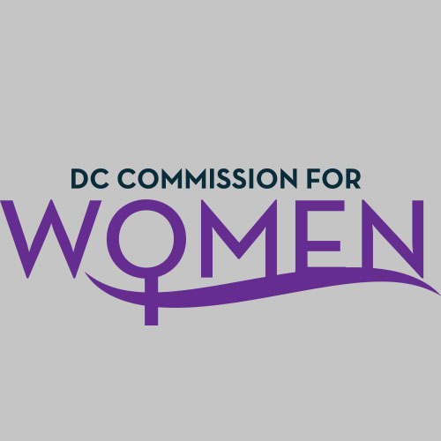
DC Commission for Women
Time: 6:45-8:00pm
Date: Tuesday, February 21, 2017
Location: John A. Wilson Building, 1350 Pennsylvania Ave. Room 527, Washington, DC 20004

- Call meeting to order: The meeting was called to order at 6:47pm
- Roll Call: The roll call was taken at 6:50pm, a quorum was met to conduct the meeting.
- Guest Speaker: Mr. Hassan Christian, Legislative Affairs Office Associate Director gave a presentation about District Government legislation.
- Director Charon Hines – The Director of Community Affairs joined our Commission meeting to say hello and highlight the efforts of the Commission. She also noted how she looks forward to working with us during Women’s History Month and the rest of 2017.
- MOWPI Staff: Shana Armstrong, Krishna Ghodiwala, and Director Kimberly Bassett.
- Approval of Previous Minutes: Minutes were circulated and accepted from the previous meeting in November.
- Correspondence: No correspondence to review.
- Unfinished Business: None
- New Business
- CHAIRWOMAN’s REPORT
  - Committee Chairs received a notice to meet with their committee members in order to discuss topics and policies to focus on for 2017.
  - Our Women’s Leadership Conference is scheduled for Fall 2017. The planning committee will convene before the next Commission meeting.
  - Vice-Chair Brockington and MOWPI is meeting with the Women’s Foundation on February 22nd, to talk about how they can support the conference later this year.

- COMMITTEE REPORTS
  - Health, Human Services, and Public Safety: Chairperson, Commissioner McDuffie
    - The focus on the committee will be violence against women for 2017.

- DIRECTOR’S REPORT:
  - Girls Conference: DC Public Schools plans to host a girls conference in June. MOWPI will act as an advisor and help promote the event.
  - We had our first session of Fresh Start Wednesday class on February 15th and Commissioner Alfonso and Christian were in attendance. Over 15 women gathered for our workshop on Resume Writing and Interview Skills facilitated by DC Department of Employment Services (DOES). The program will run every Wednesday through mid-April. Commissioners are encouraged to attend a class and welcomed to speak to the ladies about their individual life/career journey.
  - The AAUW WorkSmart Salary Negotiation Class is sold out for February 23rd. It will be held once per month at various locations. The next workshops are on March 22nd, April 4th, and April 22nd. Mayor Bowser will attend a special WorkSmart Salary Negotiation class held on Equal Pay Day, April 4th. Training sessions are being offered quarterly for any Commissioner who may be interested in becoming a facilitator.
  - Our Women of Excellence Awards are tentatively scheduled for March 16th. We have over 40 entries and are awaiting recommendations from the Mayor. If you have recommendations for potential locations, please contact Shana Armstrong.
  - March 30th is the State of the District Address at UDC’s Theater of the Arts. All Commissioners are encouraged to attend.
  - Currently, we still have vacancies on the board so if you have persons of interest, please send your recommendations to Kimberly Bassett.

- ANNOUCEMENTS
  - N/A
- Motion to Adjourn: The meeting adjourned at 7:50pm.
- Next meeting is on Tuesday, May 2nd, 2017 at 6:45pm at the Wilson Building.

