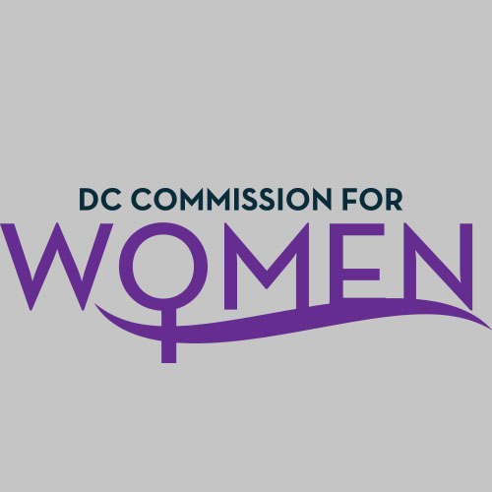

DC Commission for Women
Time: 6:45-8:00pm
Date: Thursday, Jan.14, 2016
Location: John A. Wilson Building, 1350 Pennsylvania Ave. Room G-9, Washington, DC 20004

- Call to Order: The meeting was called to order at 6:50pm
- Roll call: Commissioners in attendance.
MOWPI Staff: Director Bassett, Shana Armstrong and Krishna Ghodiwala
A Quorum is met to conduct the meeting.
- Approval of Previous Minutes: Minutes were circulated and accepted from the previous meeting.
- Correspondence/Notifications: None presented.
- Unfinished Business: None presented.
- New Business:
COMMITTEE REPORTS
HEALTH & HUMAN SERVICES: Ritu Upadhyay, Chair
- Discussed Aware and Care Initiative—to address homelessness affecting DC residents.
- Looking for volunteer opportunities with at least five homeless organizations in the city. If Commissioners have any recommendations, please contact Ritu.
PUBLIC AFFAIRS: Abby Fenton, Chair
- No report at this time. The committee will meet prior to the next meeting.
- Need recommendations of different venues for MOWPI activities and events.
PUBLIC SAFETY: Princess McDuffie, Chair
- Focus on the upcoming Girls Conference and Human Trafficking and a Self Defense class to be held during the conference. Article in Informer about a partnership with Mayor Bower and DC Police Department.

POLICY & LEGISLATIVE INITIATIVES: Endrea Frazier, Chair
- Tracking four bills: Women in Need, CEDAW, and Universal Paid Leave Act: Concerns about funding 16 weeks of leave. Bill is vague in detail.
- Bill for Domestic Violence: Hearing Jan 21st, so if anyone wants to testify, please advise.
- Women in Need Act: Partner with the Homelessness groups for supporting mental needs of women who are incarcerated, in shelters or homeless.
EDUCATION, LABOR & TRAINING COMMITTEE: Brandy Butler, Chair
- Committee is planning an event targeting girls aged 14-18. Event will create awareness around STEM education. Location has been identified but still need to finalize a date and specifics.
UPDATES FROM MOWPI DIRECTOR:
Reference the handout with all the program descriptions and calendar of events for the year.
SHE DC: Special thanks to all the Commissioners for their work in 2015. MOWPI is in the process of restructuring the program to focus more on engagement and volunteerism.
Conversations with Women who Lead is a quarterly initiative by MOWPI that began in September. Each session gathers women experts to discuss valuable career advice in a panel discussion before a young professional audience. The first series focused on women in technology and was a huge success—with an attendance of over 200 women to see United States Chief Technology Officer, Megan Smith and Mayor Bowser provided the keynote speeches. Beginning in March 2016, these sessions will held quarterly and topics will cover Nonprofits and Advocacy; Entrepreneurship; and Real Estate Development.
DC Women of Excellence Awards (March 3rd): Commissioners are asked to give nominations for dynamic women in the community to honor at the Women of Excellence Awards. Eligibility criteria were given from the MOPWI office. Final nominees are selected by Commissioners through voting ballot.
Commissioner Rudd asked Commissioners to submit a nominee and have each chair of the Education, Public Health and Public Safety committees to nominate deserving women. The Hall of Fame inductee will be added to the exhibit at the Sumner School.
MOWPI will send last year’s awardees list to commissioners.
Equal Pay Day (April 12th): Special announcement in April.
Fresh Start Wednesdays (April 6th): Average attendance for each session ranges from 18-20 people. A spring 8-week session on Fresh Start Wednesdays will begin in April with a new time of 5:00-6:30pm. The first sessions covered a range of topics but MOWPI will go in-depth with subjects that garnered the most interest including but not limited to Entrepreneurship, Branding, and Home Ownership. MOWPI met with the Mayor’s Office of Latino Affairs and they expressed interest in starting a similar program for the Latina community.
Women Equality Summit April 12th: Decision is needed whether to host the event on a Weekday or Saturday. Need to find location and speakers.
Diapers Drive: MOWPI will do a diaper drive in May in honor of Mother’s Day and to bring awareness to underserved women who cannot afford diapers.
Girls Conference: Set for May 14th but still needs a location and speakers.
Women’s Equality Day: In August 2015, MOWPI hosted its first annual Women’s Equality Day Mixer, which was an opportunity to engage hundreds of new women with District government and Mayor Bowser. In collaboration with over a dozen well-known partners, MOWPI attracted over 600 attendees to the event. Because of the overwhelming response, we plan to host this event again.
Breast Cancer Month: Because of the demand, the event around breast cancer will have to be done in Ward 7 where there is a high breast cancer rate.
Domestic Violence Awareness Month: Domestic Violence Awareness Month is in October, and MOWPI partners with a community organization in need, both homeless shelters for victims of domestic violence and their families, to host an interagency donation drive. The emphasis will be on collecting personal feminine and hygiene items—which the shelters have the most desperate need for.
MOWPI did 35 events that the Commission sponsored and/or participated in and over 100 events including those directly with the Mayor.
This weekend is the 10th Annual MLK Parade. Commissioners were asked to participate and walk together with MOWPI and mayoral staff.
A special thank you was extended to those commissioners who participated at the homeless shelters over the holidays.
Commissioners are encouraged to attend as many events as possible, because your presence makes a difference.
One of the commissioners suggested using #MOWPI16 to identify the events of MOWPI and the Commission on Social Media. It was the general consensus, with confirmation from the MOWPI Director, that the hashtag could be used.
Director Bassett indicated that approximately 200 people have signed up for SHEDC. MOWPI is looking at how best to effectively use the group. The plan moving forward is to leave enrollment open throughout the year.
Motion to Adjourn: 7:45pm
Next meeting on Feb. 4th at 6:45pm

