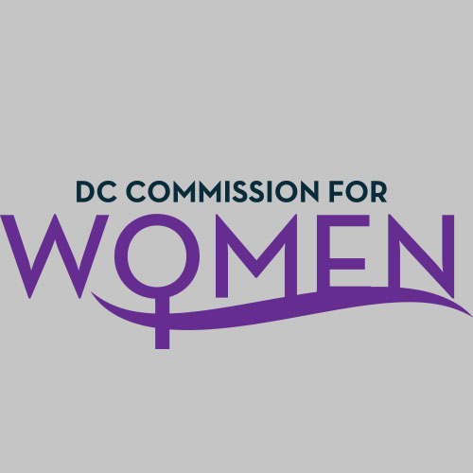

DC Commission for Women
Time: 6:45-8:00pm
Date: Thursday, July 8, 2015
Location: John A. Wilson Bldg, 1350 Pennsylvania Ave. Room G-9, Washington, DC 20004

Commissioners started calling in at 6:45pm.
- Call to Order: Conference Call Meeting called to order 6:48pm
- Roll Call: Commissioners on the call are as follows:
MOWPI Staff: Director Bassett, Shana Armstrong, and Krishna Ghodiwala
A Quorum is met to conduct the meeting.
- Approval of Minutes: Minutes were circulated from the previous meeting on June 3rd…
- Correspondence/Notification(s): Commissioner McDuffie has asked for relief of duties as Treasurer. Commissioner Rudd asked for volunteers. Commissioner Monte Monash volunteered. Her name was the only name placed in nomination.
- Election of New Treasurer: There was a unanimous voted for Commissioner Monte Monash to become the new Treasurer. Staffer Armstrong will contact her with information on duties.
- Unfinished business: None presented.
- New Business:
COMMITTEE REPORTS
POLICY COMMITTEE: ENDREA FRAZIER, CHAIR
Policy: Meeting held on Monday, June 29th. All members were present.
Ideas from the meeting included:
- Initiatives to Support Mayor Bowser’s Pathway to Middle Class.
- Ask other committees for suggestions
- Join forces with other groups
- Connect with the Community
The committee will focus on Four (4) Policies: Healthcare, Education, and Justice & Labor- Economic Empowerment. Asked each committee member to focus on two of the four areas.
The Committee will also focus on Title IX Athletic Equity Act of 2015.
The next Policy Committee conference call is the week of July 20th.
It was requested that Mayor Bowser’s Initiatives be circulated to all of the Commissioners.
PUBLIC SAFETY COMMITTEE: PRINCESS MCDUFFIE, CHAIR
Committee Initiatives/Ideas:
- Highlight Women & Girls groups
- Human Trafficking: Conversations on college campuses and in our communities
  - Also Include Homelessness as a factor related to Human Trafficking
- Self Defense class coupled with CPR training
- Campaign to target Bars and Nightclubs to not over serve women
- Domestic Violence & Dating Violence and relationships with partners
Next Steps: Work with the committee on how to implement activities and initiatives in these areas.

EDUCATION, LABOR & TRAINING COMMITTEE: BRANDY BUTLER, CHAIR
Met Thursday, July 9th at 5:30pm.
Discussed how to align the committee’s work with the Mayor’s initiative for Workforce & Education.
HEALTH & HUMAN SERVICS: RITA UPADHYAY, CHAIR
No meeting was held at this time.
PUBLIC AFFAIRS: ABBY FENTON, CHAIR
Commissioner Fenton is out of town and will schedule a meeting upon her return.
Updates from the Director of MOWPI: July 4th Events: Director Bassett, Staff and Commissioners Glover and Alfonso participated in the Barracks Road & Palisades Parades and Bruce Monroe Block Party.
MOWPI will be partnering with the Boys & Girls Club of Greater Washington, on July 10th, partnering with Google for an event at The Arc. The Mayor will speak at this event.
SHE DC has been active. The women were broken up into groups by ward and the Ward 6 women have already named themselves, WOW 6: Women of Ward 6. The proposals are due from each ward group in the coming week describing their ward/community project to be completed by the end of October.
Huge grand opening happened for the Shannon Place office building for the Mayor and Deputy Mayor Snowden, Office of Greater Economic Opportunity. The office is located in Ward 8 complete with satellite offices, meeting rooms, and event space.
Noted Events: My Sister’s Keeper Event with Federal City Chapter of Delta Sigma Theta Sorority, Inc. and Moms Matter, Saturday, July 11thfrom 2-5pm in Ward 8 at the Big Chair. Director Bassett will give remarks.
The SHE DC list currently has over 200 members and counting. MOWPI would like to see more volunteers in Ward 7 and 8.
Title IX Athletic Equity Act of 2015 came up during the week and there was a need for stronger compliance and support around it.
July 10th-- The Mayor signs an Amendment to control/reduce the spike in Synthetic Drugs use in the city. Mayor Bowser is going to sign an Emergency Amendment Act that authorizes DC police and DCRA to take swifter actions on vendors that sell these drugs.
Conversations with Women Who Lead series: Currently looking for speakers; first area of focus is Technology.
Commissioner Bishop: Asked about a calendar to update the group on upcoming events.
SHE DC : MOWPI’s action-based task force consists of girls and women from all eight wards in the District of Columbia who will assist MOWPI with executing the goals and initiatives of the office; including but not limited to: community service projects, recruiting and attending MOWPI sponsored events and growing their social media presence.
They are going to identify the issues in their Wards and The Commission will help identify the DC agencies or community partners/organizations to help with resources. Each Ward team will decide on a project or activity that will be implemented. Commissioners do not oversee the program and we do not have an active role in the program implementation.
It was requested that a list of the Ward projects be sent to the Commissioners so they can participate in events.
- Next Meeting Date: Next meeting is scheduled for Wednesday, September 2, 2015. This will be a face-to-face meeting at the Wilson Building, starting at 6:45pm.

- Adjournment: Meeting Adjourned at 7:33pm.

