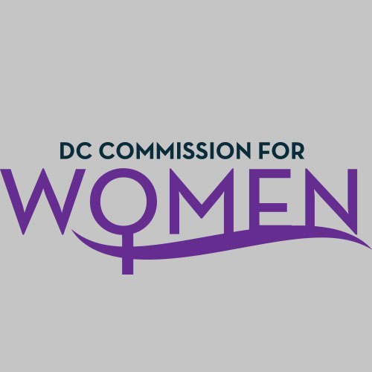
DC Commission for Women
Time: 6:45-8:00pm
Date: Thursday, April 7, 2016
Location: Wilson Building

Commissioners | Attending
Carolyn Rudd, Chairwoman | Yes
Gabrielle Alfonso | No
Ferial Bishop | Yes
Donella Brockington | Yes
Brandy Butler | No
Aryn Bussey | Yes
Courtney Christian | Yes
Abby Fenton | Yes
Endrea Frazier | No
Jacquelyn Glover | Yes
Tiffini Greene | Yes
Ann Marie Habershaw | Yes
Peg Hacskaylo | No
Shana Heilbron | Yes
Camelia Mazard | Yes
Princess McDuffie | Yes
Monte Monash | Yes
Veronica Nelson | Yes
Elizabeth O’Hara | No
Patricia Raspberry | No
Ritu Upadhyay | No

- Call meeting to order: The meeting was called to order at 6:50pm
- Roll Call: Commissioners in attendance.
- MOWPI Staff: Director Bassett, Shana Armstrong and Krishna Ghodiwala.
A quorum was met to conduct the meeting.
- Approval of Previous Minutes: Minutes were circulated and accepted from the previous meeting.

- Unfinished Business:
  - BYLAWS REVISION
    - Commissioner Bishop was able to update the Bylaws for the April Meeting. Copies were sent out yesterday. The bylaws were realigned with Roberts Rules of Order. The quorum was not clearly visible in the Bylaws. There are nine articles in the bylaws that have been presented.
    - Special committees may be established; however, they are only temporary for the specific goal or task.
    - Commissioners should review the draft and send comments to Director Bassett, Commission Chair Rudd, and Commissioner Bishop for edits to be captured.

- New Business:
- Commissioner Rudd
- A tentative Commission retreat was discussed to be scheduled during our summer hiatus.
- The Commission will be on hiatus from the month of June until August; we will reconvene in the Fall.
- Alma Brown passed this week. She was a prominent lady of the city.
  - The funeral will be at Shiloh Baptist Church on April 12th and the wake is on April 11th.

- Committee Reports: No new reports
Policy & Legislative: Councilmember Anita Bonds’ office presented two bills to improve the lives of women and families in the District. The first bill requires homeless shelters to provide free diapers and feminine hygiene products to families and individuals (B21-0692). The second bill provides an exemption for feminine hygiene products and diapers from sales tax (B21-0696).
DIRECTOR BASSETT’s Update
MOWPI currently has over 1100 Twitter followers.
A decision was made by the Commission (via a vote) to include the previous month’s meeting minutes on the website and for those interested, request other meeting minutes specifically through email. It was also decided to add a statement to the MOWPI website indicating that archival minutes may be requested by contacting the MOWPI office.
Budget oversight hearing for the MOWPI office will be on Friday, April 8th at 10:00AM.
In all eight wards, hearings are being held to discuss the design of short term housing shelters around the city.
MOWPI is doing something exciting on April 12th. We will host an Equal Pay Day Block Party with American Association of University Women (AAUW) and announce the launch of our WorkSmart Salary Negotiation classes. The Block Party is located at AAUW Headquarters from 5:00PM-7:30PM. The color of Equal Pay Day is red and the tweet is #StillNot100.
The WorkSmart Salary Negotiation Program is our newest initiative, offering DC women free salary negotiation classes across the city. It is intended to empower at least 15,000 DC women by 2021 to recognize their worth and to learn the tools and techniques of negotiating equal salaries. We will work with our partners, the AAUW and the Younger Women’s Task Force to identify and train trainers and conduct community outreach.
For the month of May, MOWPI will host its second annual diaper donation drive for the DC Diaper Bank, a local organization that collects and distributes diapers to community partners who work with underserved women who cannot afford diapers.
Fresh Start Wednesdays will begin Wednesday, June 6th at the RISE Center. This 10-week series encourages growth and development by focusing on Self-Branding, Entrepreneurship, Financial Planning and Homeownership. If Commissioners have any suggestions for possible guest speakers, please refer them to the MOWPI staffer Ms. Shana Armstrong.
Thank you to all the Commissioners who participated in the Test My Breasts Breast Cancer Walk on Saturday, April 2nd.

ANNOUCEMENTS
Commissioner Fenton informed the board members of the Whitman-Walker event for LBTQ women on Saturday, June 4th. Please refer to your email for details.

- Motion to Adjourn: The meeting adjourned at 7:45pm.
- Next meeting is on May 5, 2016 at 6:45pm at the Wilson Building.

