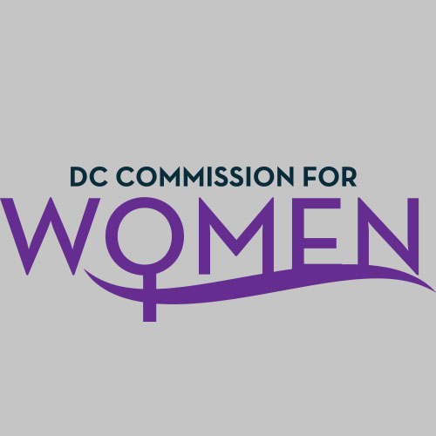
DC Commission for Women
Time: 6:45pm-8:00pm
Date: Tuesday, February 6, 2018
Location: 1350 Pennsylvania Avenue Room 527
Conference Call: 1-712-770-4700
Participant Code: 428857#
Commissioners | Attending
Carolyn Rudd, Chairwoman | Yes
Gabrielle Alfonso | Yes
Ferial Bishop | Yes
Donella Brockington | Yes
Brandy Butler | Yes
Aryn Bussey | Yes
Courtney Christian | Yes
Abby Fenton | Yes
Jacquelyn Glover | Yes
Tiffini Greene | Yes
Ann Marie Habershaw | Yes
Camelia Mazard | Yes
Princess McDuffie | Yes
Monte Monash | Yes
Veronica Nelson | Yes
Elizabeth O’Hara | No
Jennifer Porter | Yes
Susan Sarfati | No
Shelley Tomkin | Yes
Abigail Truhart | No

- Call meeting to order: The meeting was called to order at 6:50pm
- Roll Call: Roll call was completed at 6:51pm. A quorum was met.
- MOWPI Staff: Krishna Ghodiwala; Shana Armstrong
- Meeting Minutes: Meeting minutes from January 9, 2018 were circulated and approved with no edits.
- Correspondence & Announcements: None

- New Business
  - Chairwoman’s Report:
    - Dr. Rudd presented an Executive Summary for #BeTheMovement Conference, that we will use as we plan our next Leadership Conference.
    - The Chairwoman acknowledged the major events attended by Commissioners: US Conference on Mayors (African American Women Mayors Reception and DC Welcome Reception at Canadian Embassy); Health bill signing at Planned Parenthood and Conversations with Women Who Lead: Food Edition.
    - Martin Luther King Jr Parade was very well attended by MOWPI staff, Commissioners, and DC residents. Commissioners also volunteered to make toiletry kits for the homeless at the Reeves Center during National Day of Service.
    - 2018 Leadership Conference is now in the works to begin planning. Dr. Rudd is looking for volunteers now for the steering committee to meet in April, to start looking for theme and program ideas.

- Committee Reports
- Policy & Legislative Initiatives Committee: Shelley Tomkin, Chair
  - Four general areas of focus:
- Maternal Mortality—particularly among African American mothers
Alana Intrieri (Office on Policy and Legislative Affairs and Dr. Nesbitt (DC Health Director) have noted interest in working on the issue.
- Prenatal care to prevent infant deaths.
- Increase homeless women and incarcerated womens’ access to sanitary products and toiletries.
- Sexual harassment and the #MeToo movement. How do we amplify the movement locally?

B. COMMENTS Section:
- Aryn Bussey is actively working in the area of incarcerated women/returning citizens/homeless women and moving forward will inform the Commission on future projects.
- Combine Health and Human Services and Public Safety Committees to discuss how they can collaborate on above listed issues. They will present in April meeting.
- Commissioner Mazard suggested we learn more about what Council is working on to investigate how they are working on legislation in these areas.
- It was suggested to reach out to the Office on Returning Citizens for our Fresh Start Wednesday workshops. These educational workshops would be useful for the women’s future endeavors.
- Comm. Rudd noted that there are two areas that seem to be the most discussed-- homeless women and workforce sexual harassment.

- MOWPI Director’s Report:
  - The Women of Excellence Award nominee submissions have been accepted and sent to the Mayor for final review.
  - We encourage all Commissioners to attend one budget engagement forums.
  - March is Women’s History Month. Please let MOWPI staff know about any pertinent events they should attend. If you attend one of these events, send your picture to MOWPI for social media engagement.
  - For Women’s History Month, we may ask Commissioners to attend certain key events as surrogates.
  - Fresh Start Wednesdays begins March 21st at Backus Campus from 5:30-7pm. If you have suggestions for a class or want to be a speaker, please contact MOWPI staff.
  - Thanks to those who attended the Conversations with Women who Lead: Food Edition. The staff received great feedback from the community and lots of new people were added to our mailing list.
  - Women of Excellence awards event is on Sunday, March 4th

- Announcements & Good of the Order
- Dr. Rudd received positive feedback on the Executive Summary for #BeTheMovement Conference.

- Next Meeting Date: The next meeting will be on April 3, 2018 at the Wilson Building.

- Motion to Adjourn: Meeting adjourned at 7:28pm.

