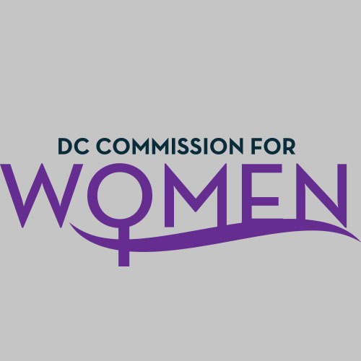
DC Commission for Women
Time: 6:45-8:00pm
Date: Thursday, Feb. 4, 2016
Location: Wilson Bldg.
- Call meeting to order: The meeting was called to order at 6:52pm
- Roll Call: Commissioners in attendance.
- MOWPI Staff: Director Bassett, Shana Armstrong and Krishna Ghodiwala.
A quorum was met to conduct the meeting.
- Approval of Previous Minutes: Minutes were circulated and accepted from the previous meeting.
- Unfinished Business: None presented.
- New Business:
- Commissioner Rudd – Prepared mandated annual report for the Mayor to review and distributed it to the Commissioners.
- Committee Reports: Please report only if you have new business.
POLICY & LEGISLATIVE INITIATIVES: Endrea Frazier, Chair
- The bill for Employment Protection for Victims of Domestic Violence. DASH Executive Director and Commissioner Hacskaylo testified before the Council. Most witnesses stated the importance of keeping the barrier low to prove Domestic Violence abuse to employers. Council is in the process of how this legislation will impact the relationship between the employer and employee.
- The Chair also discussed the Equal Pay Amendment and Protecting Pregnant Workers Fairness Acts.
HEALTH & HUMAN SERVICES: Ritu Upadhyay, Chair
- Commissioner Upadhyay was absent however, Director Bassett provided an update: The Health and Human Services committee has adopted Homelessness as an initiative. Mayor Bowser is rolling out a Homeless Agenda.
- Serve DC is having a CPR course. We want to train women and teens in the District to learn CPR. The committee would partner with Serve DC to coordinate workshops for women around DC.
- Breast Health: Last year, MOWPI held a successful event discussing breast health in Ward 7. In the District, Wards 5 and 7 have the highest rate of breast cancer.
EDUCATION, LABOR & TRAINING COMMITTEE: Brandy Butler, Chair
- The committee would like to plan an event to educate girls on Code Writing and is in the process of reviewing the strategic plan to ensure an alignment with the Mayor’s vision for the District.
PUBLIC AFFAIRS: Abby Fenton, Chair
- Commissioner Fenton discussed MOWPI’s upcoming events for the year and different ways the Public Affairs committee can help provide resources for these events.
PUBLIC SAFETY: Princess McDuffie, Chair
- Director Bassett and Chair Rudd met with Commissioner McDuffie this week. The committee will focus on spreading awareness of the sex trafficking campaign headed by the Office of Human Rights.
- In an effort to raise awareness on cyber bullying, the Public Safety Committee will partner with MOWPI to include the topic at the Girls Conference.
UPDATE FROM MOWPI DIRECTOR UPDATE
- Director Bassett gave special thanks to Dr. Rudd for the Annual Report.
- On Thursday, March 3rd, in honor of Women’s History Month, MOWPI will host the Women of Excellence Awards at 200 I Street SE at 6:30pm. Commissioners were asked to attend and promote the event. MOWPI expects 200 people to attend. Nine honorees will be celebrated for their achievements in various fields. Mistress of Ceremonies is Lesli Foster, WUSA9 Evening Anchor, and the Office of Cable Television will be onsite to film the occasion. Director Bassett announced the winners (See list below).
  - Award Winners are as follows:
    - Community Service: Khadijah Tribble
    - Education: Elayne Bennett
    - Hall of Fame: Dr. Bette Catoe-Strudwick
    - Leadership: Teri Janine Quinn
    - Public Safety: Michelle Booth Cole
    - Public Health: Beth Beck & Dr. Regina Hampton
    - Workforce Development: Gina Schafer
    - Young Leader on the Rise: Ayanna Holmes
- SHE DC postponed due to inclement weather conditions. Event is rescheduled for a spring date.
- MOWPI staffers Shana and Krishna attended the Lilly Ledbetter Fair Pay Act Anniversary Event at the White House. Secretary of Labor Thomas Perez moderated a panel discussion on equal pay and President Obama gave remarks.
- Conversations with Women Who Lead will be held on March 30th discussing non-profits and advocacy. MOWPI is currently looking for a location with a seating capacity of 200 plus people. No confirmation on keynote speakers or panelists.
- April 12th is Equal Pay Day. A press conference will be held to honor the day and promote MOWPI’s salary negotiation classes. Director Bassett asked Commissioners to volunteer to become trainers for these workshops.

GENERAL BUSINESS:
- The Women of Excellence Awards is Thursday, March 3rd.
- Commissioners voted to have a Conference Call Meeting on March 10th at 6:45PM.
- No good of the order.
Motion to Adjourn: The meeting at 7:50pm.
Next meeting is via Conference Call on March 10th, 2016 at 6:45pm.

